VWP CIA Summary - [INSERT PROJECT NAME HERE]

01/10/2022

# VAHydro Model:

## VAHydro

The comprehensive VAHydro hydrologic model is used by the DEQ Office of Water Supply to evaluate instream and off-stream beneficial uses for non-tidal surface water withdrawals throughout Virginia. This model also simulates streamflow with inputs such as precipitation, climate, land use, and topography, as well as local data collected through DEQ water supply planning and reporting programs, which includes all known withdrawals and discharges, as well as operational rules of Virginia Water Protection (VWP) permits and major hydrologic features such as reservoirs.

The VAHydro model is built on the rainfall-evaporation-runoff (RER) time-series from the Chesapeake Bay Model Phase 6. The VAHydro model simulates conditions from 1984-2014 in the Chesapeake Bay watershed drainage, and 1984-2005 in the rivers flowing outside of the Chesapeake Bay watershed. The VAHydro model features high-resolution hydrologic subsections called “river segments” (over 600 river segments in total), roughly the size of HUC 10 hydrologic units, with additional high-resolution segments added for VWP modeling projects as needed.

## Cumulative Impact Analysis (CIA)

DEQ assesses water supply sustainability through Cumulative Impact Analysis (CIA). CIA is a modeling and analysis approach that takes into account the varied hydrologic processes occurring throughout a river network (including meteorological and human water use). By simulating a daily water balance for every individual river segment within a watershed, DEQ is able to evaluate the potential “cumulative impact” of all streamflow changes occurring upstream and downstream of any location within the river system, as well as the downstream impact of a specific proposed or permitted surface water withdrawal.

The goal of the following analysis is to estimate the potential impacts of the proposed water withdrawal upon existing beneficial uses, including both in-stream and off-stream uses. In addition, cumulative impacts from all existing withdrawals are included in the evaluation.

# Project Introduction

This project consists of an existing water intake constructed in the 1960’s with an upgrade in the early 1980’s. The Town owns and operates the Big Cherry Dam located approximately 3 miles upstream from the intake structure. The Town’s water treatment plant operators control the amount of water discharging the dam into the Powell River and all of the stream by-pass flow to meet the previous permit requirements of 4.0 MOD of maximum withdrawal and 0.50 MGD of by-pass flow. This is always true unless the dam is overflowing exceeding the amount of water required from various rainfall events. Therefore, the existing/proposed maximum withdrawal amounts will not have an impact on the stream in terms of rates, volumes, frequency, etc. This is a daily activity as it serves the existing water treatment plant.

Permit: Big Cherry Dam, 01-0688  
Permit Dates: 2003-08-23 to 2018-08-22

* **Annual Withdrawal Limit** = 1168 mg/yr (3.2 mgd)
  + (historically they withdraw ~2 mgd on average)
* **Daily Withdrawal Limit** = 4 mgd
* **Flow-by** = 0.5 mgd

## Location Map

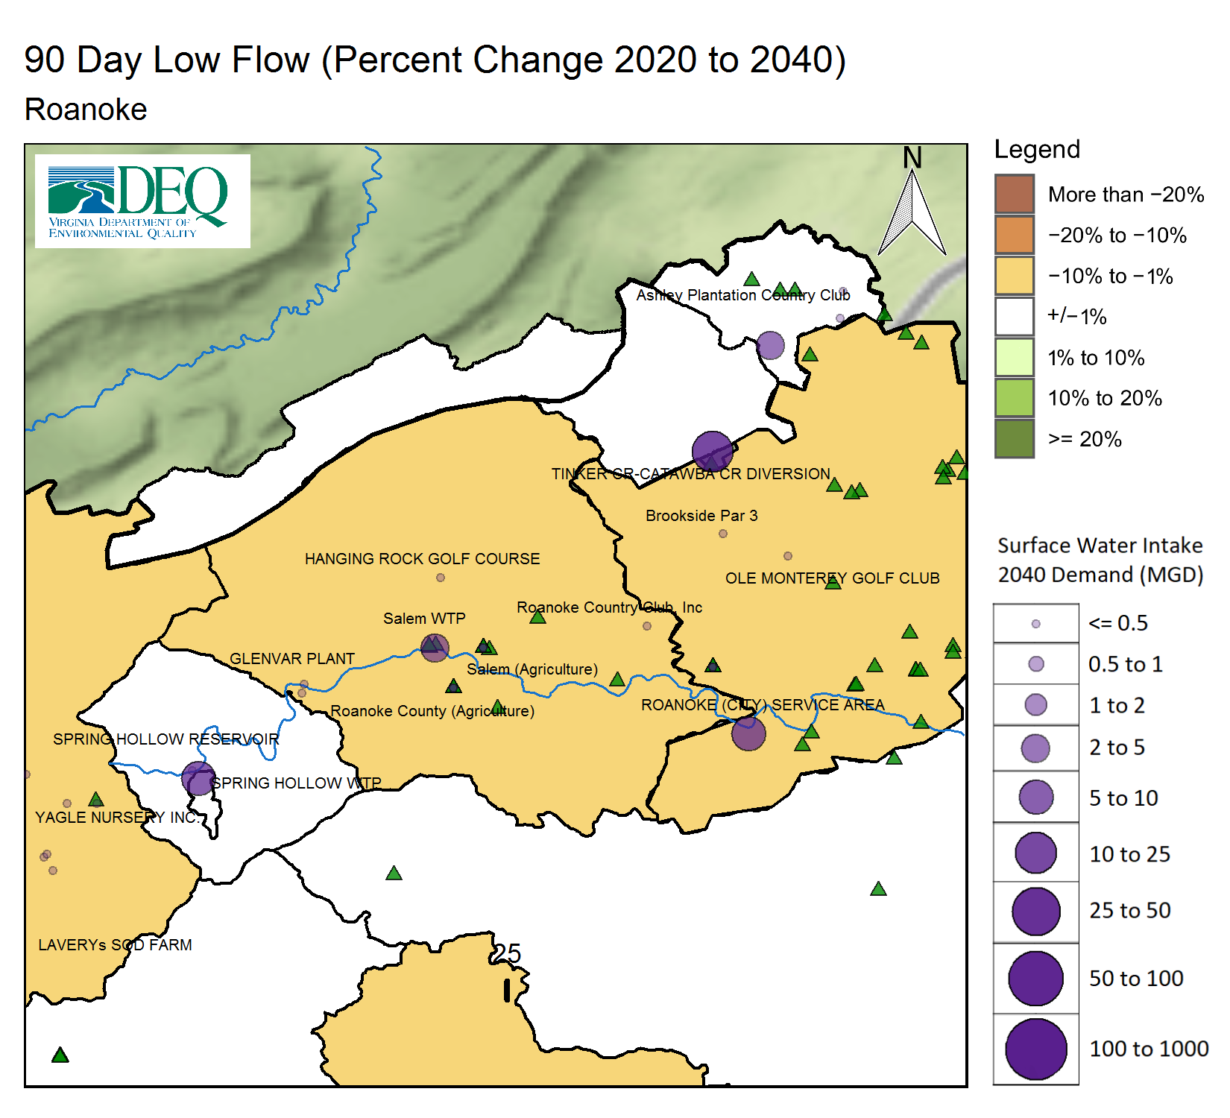

# Model Overview and Scenario Descriptions

**River Model Description** River segment model overview not provided.

**Facility & Intake Model Description** Facility intake model overview not provided.

The following model scenarios were simulated in order to determine the most effective means of meeting the project need and all other in-stream beneficial uses:

* **runid_11** - Run report information not provided.
* **runid_13** - Run report information not provided.
* **runid_18** - Run report information not provided.

**Historical Intake Flows and Drought Flow Indicators**

The VAHydro model is used to estimate flows at the project intake, including the impact of all cumulative withdrawals, discharges and management rules upstream of the withdrawal location. The models estimates of currently available flows are presented in Table 1. The Virginia Drought Assessment and Response Plan[1] employs non-exceedance flow percentiles as indicators of drought conditions at particular stream-gaging stations used to monitor drought conditions. Representative daily streamflows above the 25th percentile for return flow frequency represent normal conditions with respect to drought. Representative daily streamflows between the 10th and 25th percentiles represent drought watch conditions. Representative daily streamflows between the 5th and 10th percentiles represent drought warning conditions. Representative daily streamflows below the 5th percentile indicate drought emergency conditions.

**Table 1:** Modeled monthly current flow statistics for un-named intake in cubic feet per second (cfs). Columns show the minimum (Min) and average (Mean) modeled flow, and a range of non-exceedance flow percentiles, that is, the column header indicates the percent of flows that do *not* exceed the given value. For example, the “10%” states that only 10% of flows in the given month are expected to be less than the indicated value, and therefore, 90% of the flows in that month are expected to be greater than the given value. For example, in the table below the 10% column states that 10% of flows within the month of January would be less than 123 cfs.

| **Month** | **Min** | **5%** | **10%** | **25%** | **30%** | **50%** | **Mean** |
| --- | --- | --- | --- | --- | --- | --- | --- |
| Jan | 47 | 106 | 123 | 189 | 219 | 375 | 472 |
| Feb | 92 | 129 | 162 | 273 | 320 | 432 | 594 |
| Mar | 89 | 158 | 204 | 341 | 386 | 533 | 654 |
| Apr | 123 | 159 | 192 | 259 | 281 | 407 | 620 |
| May | 95 | 133 | 159 | 222 | 241 | 332 | 435 |
| Jun | 53 | 89 | 107 | 155 | 173 | 252 | 375 |
| Jul | 26 | 49 | 64 | 106 | 116 | 163 | 228 |
| Aug | 11 | 29 | 40 | 75 | 84 | 131 | 186 |
| Sep | 6 | 23 | 36 | 70 | 81 | 119 | 237 |
| Oct | 9 | 20 | 43 | 75 | 83 | 111 | 228 |
| Nov | 8 | 16 | 50 | 98 | 105 | 144 | 280 |
| Dec | 14 | 68 | 95 | 124 | 138 | 262 | 334 |

NULL demand_url

# Results

## Summary

Four scenarios are presented below to examine the alternatives for this permit re-issuance. A summary of how permit rules affect available water for this permit, and how this operation may impact instream beneficial uses, and other downstream water withdrawals is presented.

* **runid_11** - Run analysis not provided.
* **runid_13** - Run analysis not provided.
* **runid_18** - Run analysis not provided.

## Conclusion

* **NULL** - Preferred scenario, runid_600 , conclusions not provided. Conclusions should be stored in [model] -> 600 -> reports -> conclusions

## Detailed Cumulative Impact Analysis

The following table summarizes the cumulative impacts to flows, aquatic life, and off-stream demand for the project. The section entitled “River Segment Model Statistics” contains mean flows (Flow Out), and drought flows (30 and 90 Day Low Flow), as well as an estimated Consumptive Use Fraction (See description below) as a result of all withdrawals (Cumulative Withdrawal) and discharges (Cumulative Point Source) in the watershed. Minimum Days of Storage Remaining describes the number of days of remaining storage available during the driest period of the model simulation (applicable to impoundment models only). Total Number of Days with Storage < 50% describes the number of days in the simulation in which reservoir levels fall below 50% of full storage. The section entitled “Facility Model Statistics” shows the withdrawals, return flows (Point Source), and the model estimate for potential unmet demand due to demands exceeding the allowable withdrawal at the intake based on the cumulative conditions in the watershed and the flow-by rules in effect. There will be one or more columns in this table representing each scenario considered for this analysis.

### Glossary of Cumulative Impact Modeling Terms

* Consumptive Use (CU): This is calculated as a fraction of modeled Flow, so it is CU = 1.0 - (Flow / Flow_Baseline), where Flow_Baseline = (Flow + WD - PS), and WD and PS are the total cumulative withdrawals and point source discharges above the point in the stream. In other words, for calculating baseline flow, we take modeled outflow from the river, add the withdrawals back in, and subtract the point source in order to estimate a baseline flow balance. This almost always ends up being a higher number than the modeled Flow out, so it tells us the fraction of baseline flow that is consumed. Occasionally there are water transfers and point sources from groundwater, or point sources that cross watershed boundaries that can make the CU fraction in some watersheds negative, i.e. Flow > Flow_Baseline.

### Summary of Results:

| **Description** | **runid_11** | **runid_13** | **runid_18** |
| --- | --- | --- | --- |
| runid | 11 | 13 | 18 |
| River Segment Model Statistics: | Roanoke River (Salem) | Roanoke River (Salem) | Roanoke River (Salem) |
| Flow Out (cfs) | 385.57 | 378.64 | 344.05 |
| Minimum Days of Storage Remaining | NA | NA | NA |
| 30 Day Low Flow (cfs) | 9.6 | 7.23 | 2.74 |
| 90 Day Low Flow (cfs) | 40.28 | 37.48 | 19.25 |
| Consumptive Use Fraction | 0.05 | 0.06 | 0.15 |
| Cumulative Withdrawal (mgd) | 12 | 15.51 | 37.91 |
| Cumulative Point Source (mgd) | 0.14 | 0.17 | 0.14 |
| Facility Model Statistics: | Salem WTP:Roanoke River (Salem) | Salem WTP:Roanoke River (Salem) | Salem WTP:Roanoke River (Salem) |
| Base Demand (mgy) | NA | NA | NA |
| Withdrawal (mgy) | NA | NA | NA |
| Unmet Demand (mgy) | NA | NA | NA |
| Requested Demand (mgd) | NA | NA | NA |
| Withdrawal Met (mgd) | 2.92 | 4.63 | 15.63 |
| Point Source (mgd) | 3.33 | 5.27 | 13.86 |
| Maximum 30 day potential unmet demand (mgd) | 0 | 0.26 | 13.61 |

### Analysis of Reservoir Storage:

The following reservoir storage plots depict changes in reservoir storage under each scenario (indicated in black), as well as simulated inflow to the reservoir (blue), simulated outflow from the reservoir (green), and system demand for the given scenario (red). For water supply reservoirs, a minimum of 60 days of remaining storage over the course of the simulation is recommended. System demand varies seasonally.

[1] “No active impoundment found for run id runid_11” [1] “No active impoundment found for run id runid_13” [1] “No active impoundment found for run id runid_18”

### Analysis of Potential Unmet Demand at the River Intake:

Heatmaps are data plotting tools that help visualize data as magnitudes of color intensity. The following heatmaps depict the number of days with unmet demands for each month of the simulation (due to demands exceeding allowable withdrawal at the intake based on the cumulative conditions in the watershed and the flow-by rules in effect). The heatmap cells show the amount of unmet demand for each month [Number of Unmet Days & Amount (mgd)]. Hydrographs are shown for the period of the simulation with greatest unmet demand.

#### Hydrograph: runid_11

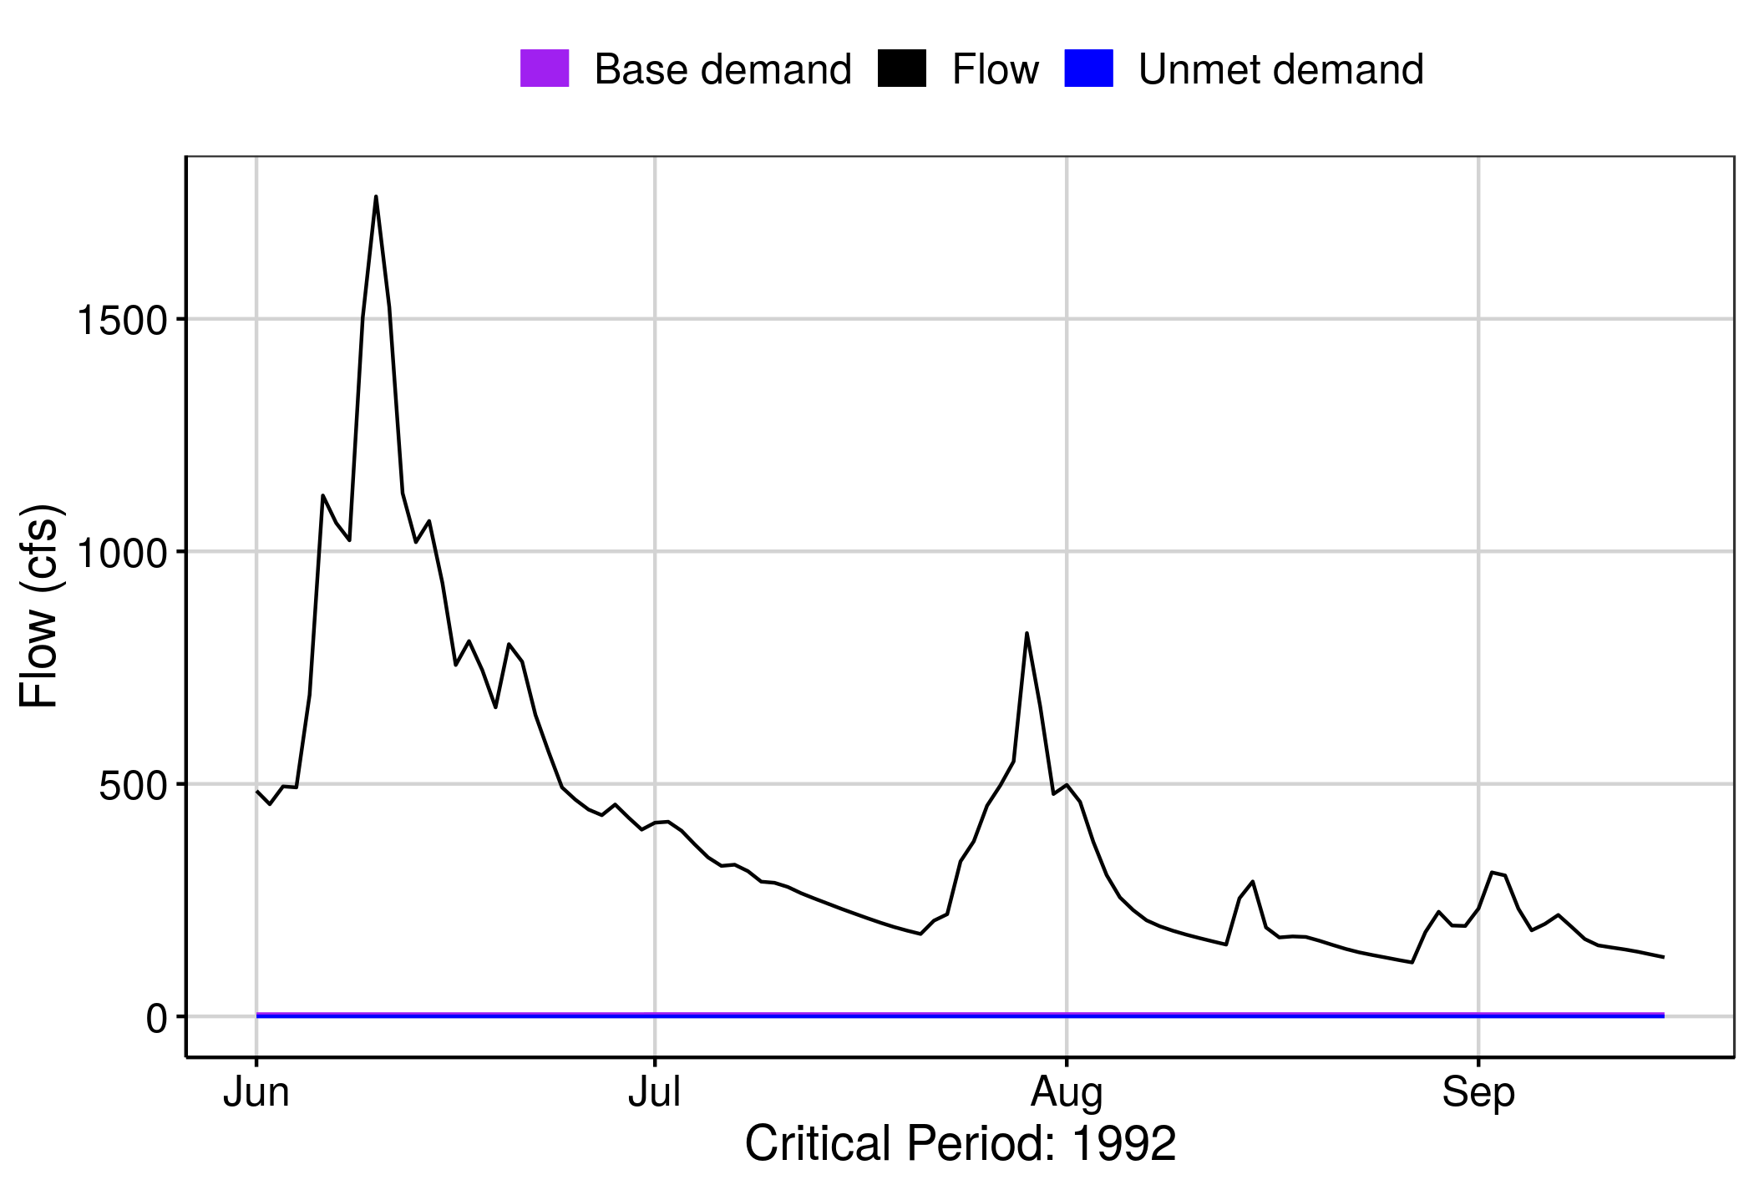 [1] “No local facility impoundment for runid_11”

#### Heatmap: runid_13

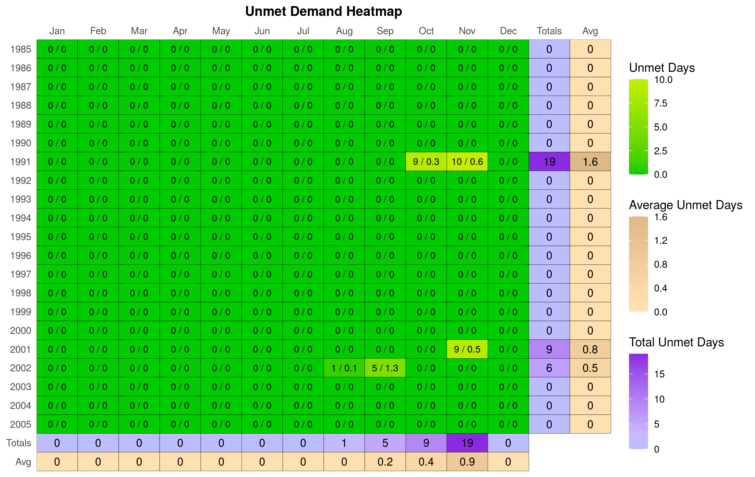

#### Hydrograph: runid_13

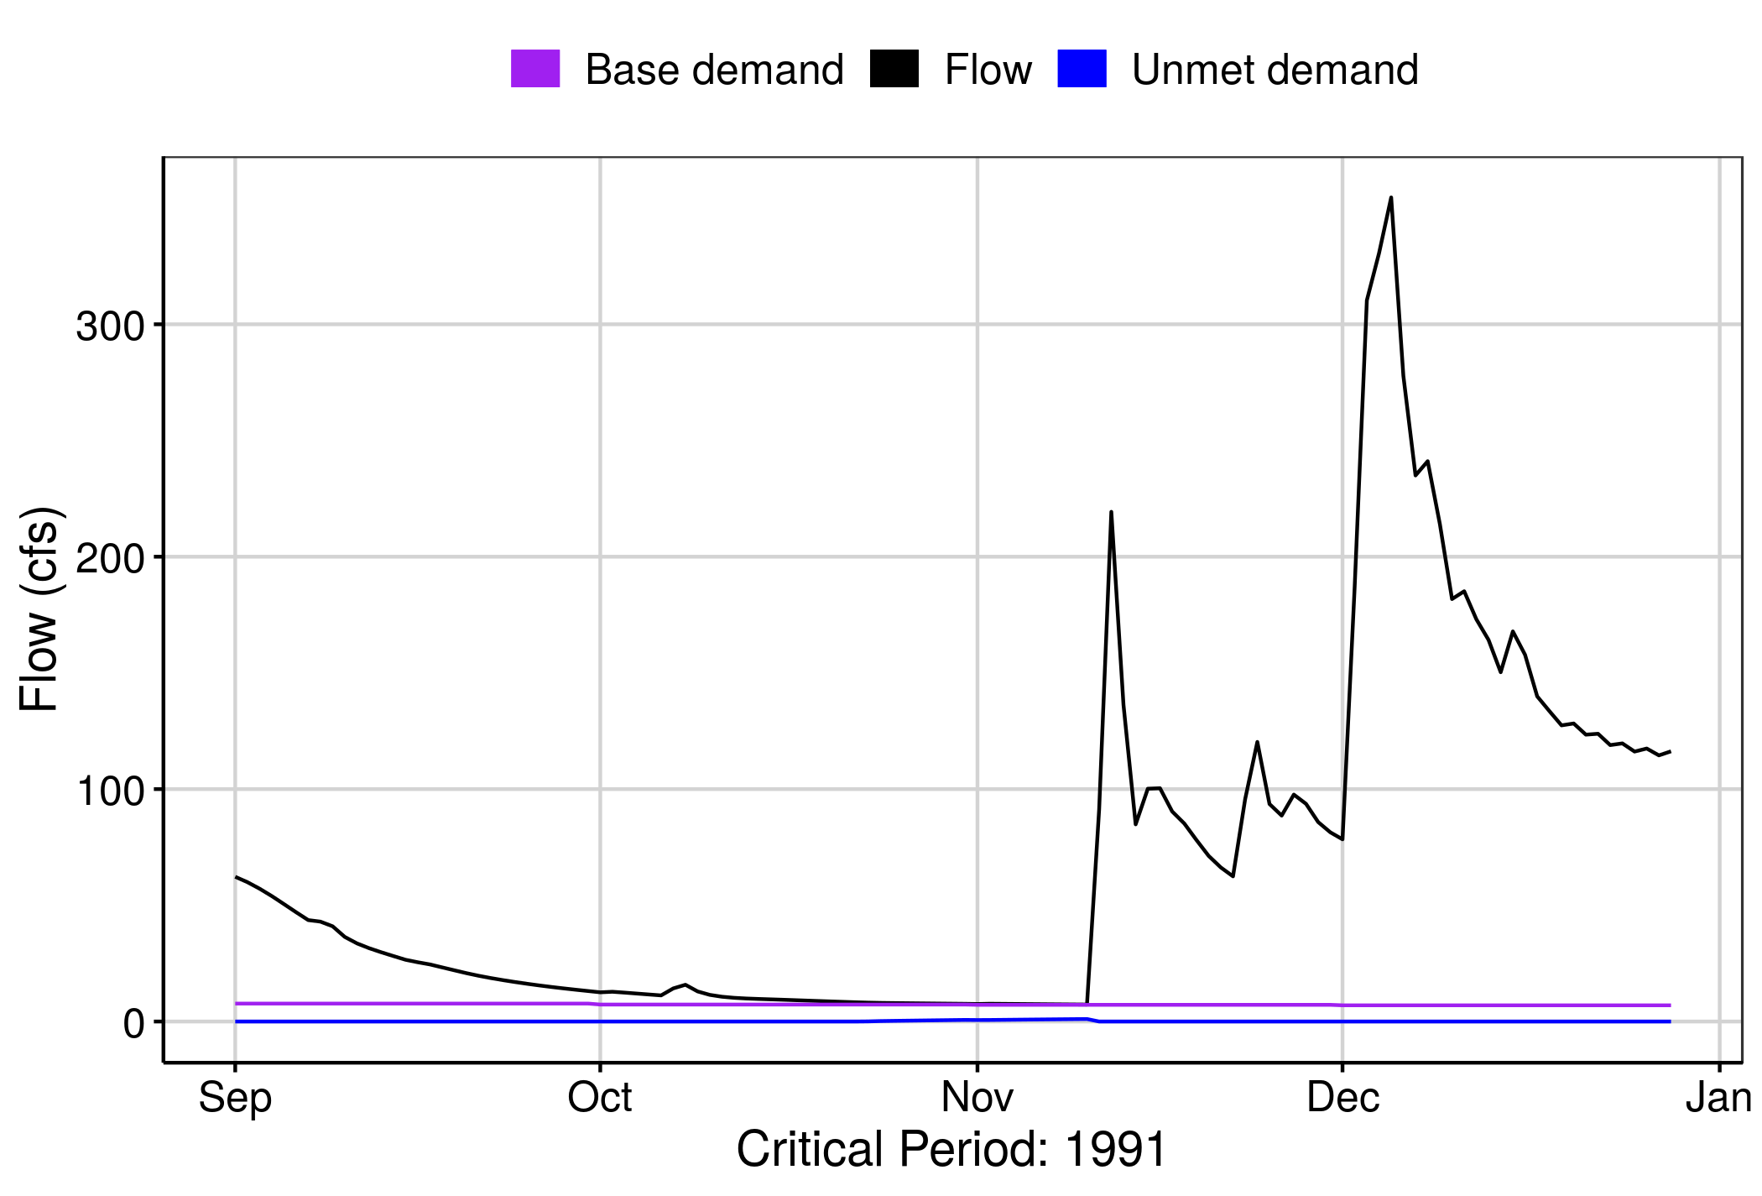 [1] “No local facility impoundment for runid_13”

#### Hydrograph: runid_18

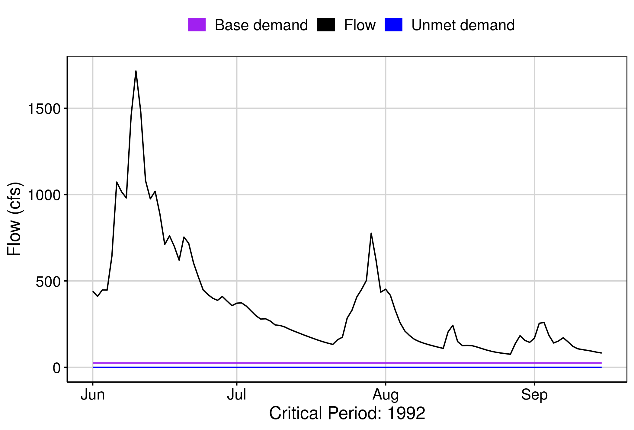 [1] “No local facility impoundment for runid_18”

# Appendix A - Ecological Impacts Assessment:

## Elfgen:

In response to a need for better environmental flow metrics, DEQ has developed a new framework for characterizing relations between streamflow and aquatic organism species richness. Part of an evolving approach to managing environmental flows for maintaining aquatic life; this methodology builds on existing minimum instream ow approaches, allowable withdrawals as a percentage of flow, and extensive flow-habitat studies. For the first time this new framework may allow quantification of potential species loss resulting from flow change, and may offer an improved understanding of aquatic life risk variability due to geographic location, stream size and local scale.

This new flow-ecology framework referred to as “elfgen” (*pronounced elf-jen*) derives its name from Ecological Limit Function (ELF) generation (*ELF-gen*). In order to calculate river segment-level richness change, elfgen is first used to produce ELFs, or relations between stream flow and species richness at the HUC 8 scale (See plot below). This is achieved using long term datasets for both ecological and hydrologic data. Ecological data (Fish species richness) is sourced from the VAHydro-EDAS dataset. Hydrologic data (Average Annual Flow) is sourced from the National Hydrography Dataset Plus. The Richness Change values presented in the table below are derived from this flow-ecology relation.

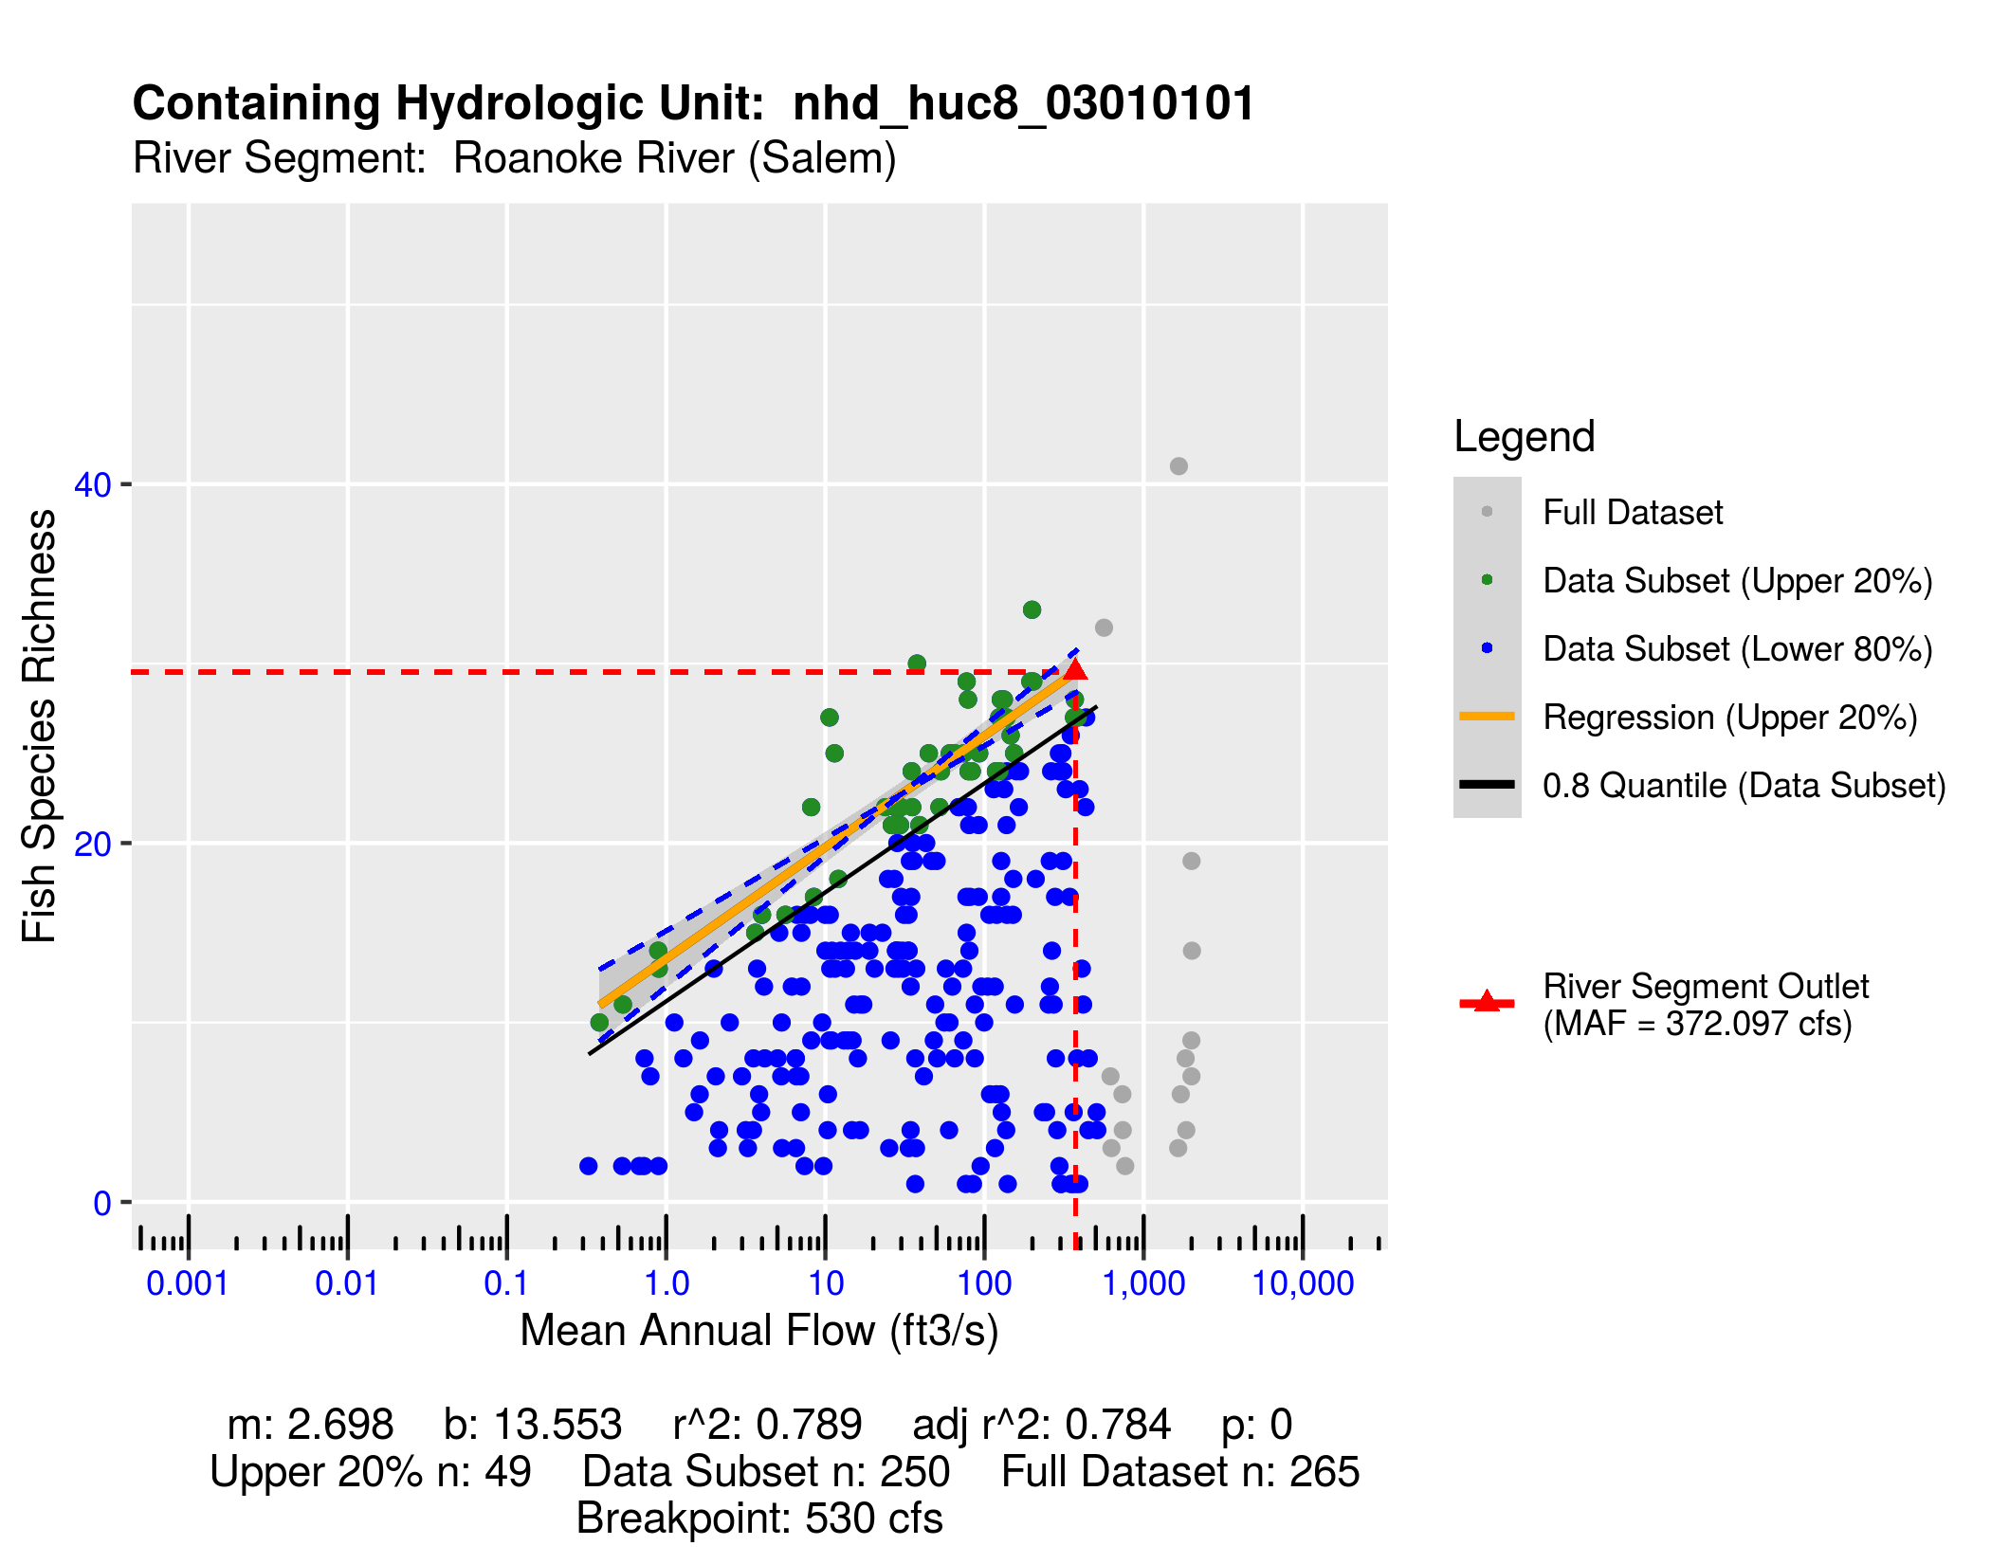

## Richness Change Metric Table:

Estimates for richness change are presented both as an absolute number of species (Richness Change (abs)) and as a percentage of the total number of species present (Richness Change (%)). Richness change calculations are derived from the estimated percent total consumptive use (For additional details on “elfgen” methodology, see <https://onlinelibrary.wiley.com/doi/full/10.1111/1752-1688.12876>).

| **Description** | **runid_11** | **runid_13** | **runid_18** |
| --- | --- | --- | --- |
| River Segment Model Statistics: | Roanoke River (Salem) | Roanoke River (Salem) | Roanoke River (Salem) |
| Consumptive Use Fraction | 0.05 | 0.06 | 0.15 |
| Cumulative Withdrawal (mgd) | 12 | 15.51 | 37.91 |
| Richness Change (abs) | -0.13 | -0.16 | -0.42 |
| Richness Change (%) | -0.42 | -0.56 | -1.43 |

## Habitat (If Applicable):

# Appendix B - Nearby Users Table:

|  | **Sub-Watershed** | **MP Type** | **MP Status** | **MP Name** | **MP 5-yr Avg Use (MGY)** | **Facility Name** | **Facility 5-yr Avg Use (MGY)** | **Facility 2040 Use (MGY)** |
| --- | --- | --- | --- | --- | --- | --- | --- | --- |
| 1 | Carvins Cove Reservoir | intake | active | FROM CARVINS COVE RESERVOIR | 2,972.10 | ROANOKE (CITY) SERVICE AREA | 5,066.55 | 10,283.45 |
| 2 | Roanoke River (Roanoke) | intake | active | CRYSTAL SPRING | 1,709.23 | ROANOKE (CITY) SERVICE AREA | 5,066.55 | 10,283.45 |
| 3 | Roanoke River (Salem) | intake | active | ROANOKE RIVER | 1,063.84 | Salem WTP | 1,521.20 | 2,345.65 |
| 4 | Roanoke River (Salem) | well | active | WELL #2 | 282.87 | Salem WTP | 1,521.20 | 2,345.65 |
| 5 | Roanoke River (Roanoke) | well | active | GARDEN CITY WELL #2 | 174.57 | ROANOKE (CITY) SERVICE AREA | 5,066.55 | 10,283.45 |
| 6 | Tinker Creek | intake | active | TINKER CREEK | 146.97 | TINKER CR-CATAWBA CR DIVERSION | 577.44 | 2,122.04 |
| 7 | Roanoke River (Roanoke) | well | active | MUSE SPRING WELL | 146.60 | ROANOKE (CITY) SERVICE AREA | 5,066.55 | 10,283.45 |
| 8 | Roanoke River (Salem) | well | active | WELL #1 | 131.56 | Salem WTP | 1,521.20 | 2,345.65 |
| 9 | Roanoke River (Salem) | well | active | WELL #1 | 75.56 | ROANOKE PLANT | 75.56 | 0.00 |
| 10 | Roanoke River (Roanoke) | well | active | MANSARD SQUARE WELL | 54.73 | VINTON SERVICE AREA | 295.18 | 592.16 |
| 11 | Roanoke River (Roanoke) | well | active | BUSH WELL #2 | 51.50 | VINTON SERVICE AREA | 295.18 | 592.16 |
| 12 | Roanoke River (Salem) | well | active | WELL #3 | 42.93 | Salem WTP | 1,521.20 | 2,345.65 |
| 13 | Roanoke River (Roanoke) | well | active | CRAIG AVE WELL | 41.50 | VINTON SERVICE AREA | 295.18 | 592.16 |
| 14 | Roanoke River (Roanoke) | intake | active | MUSE SPRING TO FRED WHITAKER | 38.30 | ROANOKE (CITY) SERVICE AREA | 5,066.55 | 10,283.45 |
| 15 | Roanoke River (Roanoke) | well | active | STONEBRIDGE WELL | 34.28 | VINTON SERVICE AREA | 295.18 | 592.16 |
| 16 | Roanoke River (Roanoke) | well | active | BUSH WELL #1 | 31.48 | VINTON SERVICE AREA | 295.18 | 592.16 |
| 17 | Roanoke River (Roanoke) | well | active | WELL #1 | 27.71 | TROUTVILLE SERVICE AREA | 49.34 | 95.05 |
| 18 | Roanoke River (Roanoke) | well | active | CHESTNUT STREET WELL | 26.68 | VINTON SERVICE AREA | 295.18 | 592.16 |
| 19 | Roanoke River (Salem) | intake | active | Irrigation Pond | 26.66 | Roanoke Country Club, Inc | 26.66 | 0.00 |
| 20 | Roanoke River (Roanoke) | well | active | Well #1 | 25.54 | BALLYHACK GOLF CLUB | 25.54 | 0.00 |
| 21 | Roanoke River (Salem) | well | active | BACK WELL | 23.40 | SALEM PLANT | 23.40 | 0.00 |
| 22 | Roanoke River (Roanoke) | well | active | SPRING GROVE WELL | 19.70 | VINTON SERVICE AREA | 295.18 | 592.16 |
| 23 | Roanoke River (Roanoke) | well | active | ROUTE 24 WELL | 17.83 | VINTON SERVICE AREA | 295.18 | 592.16 |
| 24 | Roanoke River (Roanoke) | well | active | MELISSA WELL | 17.50 | VINTON SERVICE AREA | 295.18 | 592.16 |
| 25 | Roanoke River (Salem) | well | active | #13 WELL | 15.85 | HIDDEN VALLEY COUNTRY CLUB | 15.85 | 26.95 |
| 26 | Roanoke River (Roanoke) | well | active | Mountain View Well 12 | 15.48 | APPLE TREE VILLAGE S3/STEEPLEC | 70.18 | 78.82 |
| 27 | Roanoke River (Salem) | intake | active | IRRIGATION POND | 15.05 | HANGING ROCK GOLF COURSE | 15.05 | 23.62 |
| 28 | Roanoke River (Roanoke) | well | active | Well #2 | 13.17 | white oak estates | 21.10 | 16.71 |
| 29 | Roanoke River (Roanoke) | well | active | WELL #5 | 12.98 | RAINBOW FOREST SERVICE AREA | 39.13 | 59.52 |
| 30 | Roanoke River (Roanoke) | well | active | WELL #1 | 11.44 | BLUE HILLS GOLF CORP. | 11.44 | 22.55 |
| 31 | Roanoke River (Roanoke) | well | active | WELL #1 | 10.64 | RAINBOW FOREST SERVICE AREA | 39.13 | 59.52 |
| 32 | Roanoke River (Roanoke) | well | active | Well #1 | 7.92 | white oak estates | 21.10 | 16.71 |
| 33 | Roanoke River (Roanoke) | well | active | WELL #2 | 7.65 | RAINBOW FOREST SERVICE AREA | 39.13 | 59.52 |
| 34 | Roanoke River (Roanoke) | well | active | WELL #3 | 7.51 | TROUTVILLE SERVICE AREA | 49.34 | 95.05 |
| 35 | Roanoke River (Roanoke) | well | active | OAKWOOD / PARKVIEW WELL #2 | 6.12 | OAKWOOD SERVICE AREA | 16.83 | 13.53 |
| 36 | Roanoke River (Roanoke) | well | active | MT VIEW WELL 7\APPLE TREE | 5.93 | APPLE TREE VILLAGE S3/STEEPLEC | 70.18 | 78.82 |
| 37 | Roanoke River (Salem) | well | active | NORTH LAKES WELL #6 | 5.40 | NORTH LAKES SERVICE AREA | 5.40 | 0.00 |
| 38 | Roanoke River (Roanoke) | well | active | WELL #2 CLEARVIEW ESTATES | 5.31 | RAINBOW FOREST SERVICE AREA | 39.13 | 59.52 |
| 39 | Roanoke River (Roanoke) | well | active | British Woods Well #1 | 4.62 | British Woods | 0.00 | 0.00 |
| 40 | Roanoke River (Roanoke) | well | active | MT VIEW WELL 6\APPLE TREE | 3.54 | APPLE TREE VILLAGE S3/STEEPLEC | 70.18 | 78.82 |
| 41 | Roanoke River (Roanoke) | well | active | WELL #2 | 2.95 | STRATFORD PLACE SERVICE AREA | 3.06 | 10.73 |
| 42 | Roanoke River (Roanoke) | well | active | OAKWOOD / PARKVIEW WELL #4 | 2.71 | OAKWOOD SERVICE AREA | 16.83 | 13.53 |
| 43 | Roanoke River (Roanoke) | well | active | WELL #4 | 2.55 | RAINBOW FOREST SERVICE AREA | 39.13 | 59.52 |
| 44 | Tinker Creek | well | active | Dal-Nita Hills | 2.52 | DAL-NITA HILLS, KESWICK FARMS & TINKERVIEW GRDNS | 3.97 | 3.51 |
| 45 | Roanoke River (Roanoke) | well | active | OAKWOOD / PARKVIEW WELL #1 | 2.38 | OAKWOOD SERVICE AREA | 16.83 | 13.53 |
| 46 | Roanoke River (Roanoke) | well | active | Well 1 | 1.85 | HEATHERSTONE | 3.96 | 9.48 |
| 47 | Roanoke River (Salem) | intake | active | ROANOKE RIVER | 1.71 | GLENVAR PLANT | 1.71 | 8.76 |
| 48 | Tinker Creek | well | active | Keswick Farms | 1.08 | DAL-NITA HILLS, KESWICK FARMS & TINKERVIEW GRDNS | 3.97 | 3.51 |
| 49 | Roanoke River (Roanoke) | well | active | WELL #2 | 0.99 | BLUE RIDGE HGHTS SERVICE AREA | 9.28 | 10.75 |
| 50 | Roanoke River (Roanoke) | intake | active | GLADE CREEK | 0.69 | PLANT 35 AND 36 | 0.69 | 0.00 |
| 51 | Roanoke River (Salem) | intake | active | ROANOKE RIVER | 0.42 | LAVERYs SOD FARM | 29.63 | 36.09 |
| 52 | Roanoke River (Roanoke) | well | active | WELL #1 | 0.10 | STRATFORD PLACE SERVICE AREA | 3.06 | 10.73 |
| 53 | Tinker Creek | well | inactive | GREENFIELD WELL #3 | 0.02 | GREENFIELD | 0.03 | 0.00 |
| 54 | Tinker Creek | well | inactive | GREENFIELD WELL #4 | 0.01 | GREENFIELD | 0.03 | 0.00 |
| 55 | Roanoke River (Roanoke) | well | inactive | SOUTHERN HILLS WELL | 0.00 | ROANOKE (CITY) SERVICE AREA | 5,066.55 | 10,283.45 |
| 56 | Roanoke River (Roanoke) | well | inactive | NEW HOPE WELL | 0.00 | ROANOKE (CITY) SERVICE AREA | 5,066.55 | 10,283.45 |
| 57 | Roanoke River (Salem) | intake | inactive | SALEM OLD WTP 1 ROANOKE RIVER | 0.00 | Salem WTP | 1,521.20 | 2,345.65 |
| 58 | Roanoke River (Roanoke) | well | inactive | FALLING CR EST WELL 3 TODDBRY | 0.00 | VINTON SERVICE AREA | 295.18 | 592.16 |
| 59 | Roanoke River (Roanoke) | well | inactive | FALLING CREEK WELL B | 0.00 | VINTON SERVICE AREA | 295.18 | 592.16 |
| 60 | Roanoke River (Roanoke) | well | inactive | FALLING CREEK EST WELL A | 0.00 | VINTON SERVICE AREA | 295.18 | 592.16 |
| 61 | Roanoke River (Roanoke) | well | active | BUSH WELL #3 | 0.00 | VINTON SERVICE AREA | 295.18 | 592.16 |
| 62 | Roanoke River (Roanoke) | well | inactive | FALLING CR EST WELL 1 TWIN MT | 0.00 | VINTON SERVICE AREA | 295.18 | 592.16 |
| 63 | Roanoke River (Roanoke) | well | inactive | MT VIEW WELL #2 BIRCHWOOD | 0.00 | APPLE TREE VILLAGE S3/STEEPLEC | 70.18 | 78.82 |
| 64 | Roanoke River (Roanoke) | well | inactive | OAKCREST WELL #4 | 0.00 | OAKWOOD SERVICE AREA | 16.83 | 13.53 |
| 65 | Roanoke River (Roanoke) | well | active | WELL #1 | 0.00 | BLUE RIDGE HGHTS SERVICE AREA | 9.28 | 10.75 |
| 66 | Roanoke River (Salem) | well | active | WELL #1 BOILER | 0.00 | GLENVAR PLANT | 1.71 | 8.76 |
| 67 | Roanoke River (Roanoke) | intake | inactive | SPRING | 0.00 | DAL-NITA HILLS, KESWICK FARMS & TINKERVIEW GRDNS | 3.97 | 3.51 |
| 68 | Roanoke River (Salem) | intake | active | ROANOKE RIVER | 0.00 | ROANOKE FACILITIES | 0.00 | 0.00 |
| 69 | Roanoke River (Roanoke) | well | inactive | NORTH SERVICE AREA WELL #6 | 0.00 | NORTH SERVICE AREA | 0.00 | 0.00 |
| 70 | Roanoke River (Salem) | well | inactive | BRIDLEWOOD WELL #3 | 0.00 | SOUTH SERVICE AREA | 0.00 | 0.00 |
| 71 | Roanoke River (Salem) | well | active | WELL #1 | 0.00 | Emulsion Plant | 0.00 | 0.00 |
| 72 | Roanoke River (Salem) | intake | inactive | ROANOKE RIVER GLENVAR WTP 2 | 0.00 | SALEM GLENVAR WTP 2 | 0.00 | 0.00 |
| 73 | Tinker Creek | intake | active | 220 Pump | 0.00 | Ashley Plantation Country Club | 0.00 | 0.00 |
| 74 | Tinker Creek | intake | active | #4 Pond | 0.00 | Ashley Plantation Country Club | 0.00 | 0.00 |
| 75 | Roanoke River (Roanoke) | intake | active | Tinker Creek | 0.00 | OLE MONTEREY GOLF CLUB | 0.00 | 0.00 |
| 76 | Roanoke River (Roanoke) | intake | active | Deer Branch | 0.00 | Brookside Par 3 | 0.00 | 0.00 |
| 77 | Roanoke River (Roanoke) | well | inactive | SOUTHERN HILLS WELL | 0.00 | SOUTHERN HILLS | 0.00 | 0.00 |
| 78 | Roanoke River (Salem) | well | inactive | CRESTHILL #1 | 0.00 | OAK GROVE SERVICE AREA | 0.00 | 0.00 |
| 79 | Roanoke River (Salem) | well | active | WELL #1 | 0.00 | VIRGINIA BAPTIST CHILDREN HOME | 0.00 | 0.00 |
| 80 | Roanoke River (Roanoke) | well | inactive | BURLINGTON HEIGHTS WELL | 0.00 | BURLINGTON HEIGHT SERVICE AREA | 0.00 | 0.00 |
| 81 | Roanoke River (Salem) | well | inactive | CRESTWOOD PARK WELL | 0.00 | CRESTWOOD PARK SERVICE AREA | 0.00 | 0.00 |
| 82 | Roanoke River (Roanoke) | well | inactive | WELL #3 | 0.00 | DALEVILLE SERVICE AREA | 0.00 | 0.00 |
| 83 | Roanoke River (Salem) | well | active | LONGRIDGE WELL #2 | 0.00 | LONGRIDGE SERVICE AREA | 0.00 | 0.00 |
| 84 | Roanoke River (Roanoke) | well | inactive | AVENHAM\HUNTING HILLS WELL | 0.00 | AVENHAM\HUNTING HILLS SER AREA | 0.00 | 0.00 |
| 85 | Roanoke River (Salem) | well | inactive | SOUTHWOODS #2 | 0.00 | OAK GROVE SERVICE AREA | 0.00 | 0.00 |
| 86 | Roanoke River (Roanoke) | well | active | HUNT RIDGE WELL | 0.00 | 460 EAST | 0.00 | 0.00 |
| 87 | Roanoke River (Roanoke) | well | active | BONSACK #1 WELL | 0.00 | 460 EAST | 0.00 | 0.00 |
| 88 | Roanoke River (Salem) | well | inactive | PENN FOREST WELL #1 | 0.00 | PENN FOREST SERVICE AREA | 42.48 | 0.00 |
| 89 | Roanoke River (Salem) | well | active | CHEROKEE HILLS WELL #1 | 0.00 | CHEROKEE HILLS | 0.00 | 0.00 |
| 90 | Roanoke River (Salem) | well | active | CHEROKEE HILLS WELL #4 | 0.00 | CHEROKEE HILLS | 0.00 | 0.00 |
| 91 | Roanoke River (Salem) | well | inactive | GREEN HAVEN HILLS WELL | 0.00 | GREEN HAVEN HILLS SERVICE AREA | 0.00 | 0.00 |
| 92 | Roanoke River (Roanoke) | well | inactive | STARMOUNT #2 | 0.00 | NORTH SERVICE AREA | 0.00 | 0.00 |
| 93 | Roanoke River (Roanoke) | well | inactive | NORTH SERVICE AREA WELL #5 | 0.00 | NORTH SERVICE AREA | 0.00 | 0.00 |
| 94 | Roanoke River (Salem) | well | inactive | OAK GROVE WELL | 0.00 | OAK GROVE SERVICE AREA | 0.00 | 0.00 |
| 95 | Roanoke River (Salem) | well | inactive | HIGHFIELDS WELL #2 | 0.00 | HIGHFIELDS SERVICE AREA | 0.00 | 0.00 |
| 96 | Roanoke River (Roanoke) | well | active | WELL #1 | 0.00 | ROANOKE PLANT | 0.00 | 0.00 |
| 97 | Roanoke River (Salem) | well | inactive | HIGHFIELDS WELL #1 | 0.00 | HIGHFIELDS SERVICE AREA | 0.00 | 0.00 |
| 98 | Roanoke River (Salem) | well | inactive | LAYMAN LAWN WELL #1 | 0.00 | LAYMAN LAWN SERVICE AREA | 0.00 | 0.00 |
| 99 | Roanoke River (Roanoke) | well | inactive | VISTA PARK WELL | 0.00 | CLOVERDALE - VISTA PARK | 0.00 | 0.00 |
| 100 | Roanoke River (Salem) | well | inactive | NORTH LAKES WELL #2 | 0.00 | NORTH LAKES SERVICE AREA | 5.40 | 0.00 |
| 101 | Roanoke River (Salem) | well | inactive | NORTH LAKES WELL #4 | 0.00 | NORTH LAKES SERVICE AREA | 5.40 | 0.00 |
| 102 | Roanoke River (Roanoke) | well | active | WELL #7 | 0.00 | COUNTRYSIDE GOLF COURSE | 0.00 | 0.00 |
| 103 | Roanoke River (Roanoke) | well | inactive | TINKER KNOLL WELL #1 | 0.00 | NORTH SERVICE AREA | 0.00 | 0.00 |
| 104 | Roanoke River (Salem) | well | inactive | SOUTHWOODS #1 | 0.00 | OAK GROVE SERVICE AREA | 0.00 | 0.00 |
| 105 | Roanoke River (Roanoke) | well | inactive | STARMOUNT #1 | 0.00 | NORTH SERVICE AREA | 0.00 | 0.00 |
| 106 | Roanoke River (Salem) | well | inactive | BELLE MEADE WELL | 0.00 | BELLE MEADE SERVICE AREA | 0.00 | 0.00 |
| 107 | Roanoke River (Roanoke) | well | inactive | CHESTERFIELD COURT WELL | 0.00 | CHESTERFIELD CT SERVICE AREA | 0.00 | 0.00 |
| 108 | Roanoke River (Salem) | well | inactive | CHESTERFIELD COURT WELL | 0.00 | CHESTERFIELD CT SERVICE AREA | 0.00 | 0.00 |
| 109 | Roanoke River (Salem) | well | inactive | CASTLE ROCK WELL #1 | 0.00 | CASTLE ROCK SERVICE AREA | 0.00 | 0.00 |
| 110 | Roanoke River (Salem) | well | inactive | GRISSO WELL - PENN FOREST | 0.00 | PENN FOREST SERVICE AREA | 42.48 | 0.00 |
| 111 | Roanoke River (Salem) | well | inactive | HOMEWOOD WELL #1 | 0.00 | HOMEWOOD SERVICE AREA | 0.00 | 0.00 |
| 112 | Roanoke River (Salem) | well | inactive | WESTERN HILLS WELL | 0.00 | OAK GROVE SERVICE AREA | 0.00 | 0.00 |
| 113 | Roanoke River (Salem) | well | active | FRONT WELL | 0.00 | SALEM PLANT | 23.40 | 0.00 |
| 114 | Roanoke River (Salem) | well | inactive | ARLINGTON HILLS WELL #3 | 0.00 | PENN FOREST SERVICE AREA | 42.48 | 0.00 |
| 115 | Roanoke River (Roanoke) | well | inactive | HAMPDEN HILLS WELL #2 | 0.00 | HAMPDEN HILLS SERVICE AREA | 0.00 | 0.00 |
| 116 | Roanoke River (Salem) | well | inactive | NORTH LAKES WELL #1 | 0.00 | NORTH LAKES SERVICE AREA | 5.40 | 0.00 |
| 117 | Roanoke River (Salem) | well | inactive | FARMINGDALE WELL | 0.00 | FARMINGDALE SERVICE AREA | 0.00 | 0.00 |
| 118 | Roanoke River (Roanoke) | well | active | WELL #8 | 0.00 | COUNTRYSIDE GOLF COURSE | 0.00 | 0.00 |
| 119 | Roanoke River (Roanoke) | well | inactive | BELLE HAVEN WELL | 0.00 | BELLE HAVEN SERVICE AREA | 0.00 | 0.00 |
| 120 | Roanoke River (Salem) | well | inactive | NORTH LAKES WELL #3 | 0.00 | NORTH LAKES SERVICE AREA | 5.40 | 0.00 |
| 121 | Roanoke River (Roanoke) | well | active | WELL #1 | 0.00 | ORCHARD APPLETREE BOTETOURT E | 0.00 | 0.00 |
| 122 | Roanoke River (Salem) | well | active | LONGRIDGE WELL #1 | 0.00 | LONGRIDGE SERVICE AREA | 0.00 | 0.00 |
| 123 | Roanoke River (Roanoke) | well | inactive | LABELLEVUE WELL #7 | 0.00 | LABELLEVUE SERVICE AREA | 0.00 | 0.00 |
| 124 | Roanoke River (Roanoke) | well | active | LABELLEVUE WELL #2 | 0.00 | LABELLEVUE SERVICE AREA | 0.00 | 0.00 |
| 125 | Roanoke River (Roanoke) | well | inactive | HOLLINS WELL | 0.00 | HOLLINS SERVICE AREA | 0.00 | 0.00 |
| 126 | Roanoke River (Roanoke) | well | inactive | DEER RUN | 0.00 | NORTH SERVICE AREA | 0.00 | 0.00 |
| 127 | Roanoke River (Roanoke) | well | inactive | CARVINS MEADOW WELL | 0.00 | CARVINS MEADOW SERVICE AREA | 0.00 | 0.00 |
| 128 | Roanoke River (Salem) | well | inactive | WOODED ACRES WELL | 0.00 | WOODED ACRES SERVICE AREA | 0.00 | 0.00 |
| 129 | Roanoke River (Roanoke) | well | inactive | NORTH SERVICE AREA WELL #1 | 0.00 | NORTH SERVICE AREA | 0.00 | 0.00 |
| 130 | Roanoke River (Roanoke) | well | active | WELL #3 | 0.00 | ORCHARD APPLETREE BOTETOURT E | 0.00 | 0.00 |
| 131 | Roanoke River (Roanoke) | well | active | WELL #2 | 0.00 | ORCHARD APPLETREE BOTETOURT E | 0.00 | 0.00 |
| 132 | Roanoke River (Roanoke) | well | active | HAMPDEN HILLS WELL #1 | 0.00 | HAMPDEN HILLS SERVICE AREA | 0.00 | 0.00 |
| 133 | Roanoke River (Salem) | well | active | HIDDEN VALLEY WELL #9 | 0.00 | HIDDEN VALLEY SERVICE AREA | 0.00 | 0.00 |
| 134 | Roanoke River (Salem) | well | inactive | WYNDALE WELL | 0.00 | OAK GROVE SERVICE AREA | 0.00 | 0.00 |
| 135 | Roanoke River (Salem) | well | inactive | ANDREW LEWIS PLACE WELL | 0.00 | ANDREW LEWIS PLACE SERV AREA | 0.00 | 0.00 |
| 136 | Roanoke River (Roanoke) | well | active | LABELLEVUE WELL #4 | 0.00 | LABELLEVUE SERVICE AREA | 0.00 | 0.00 |

1. [Virginia Drought Assessment and Response Plan](https://www.deq.virginia.gov/home/showpublisheddocument/5115/637490843054630000), developed by the Drought Response Technical Advisory Committee in response to Executive Order #39, March 28, 2003.